1

Introduction:   
What Is Economics?

Chapter Summary

Chapter 1 provides a basic illustration of what economics is and why it is useful. Economics is the study of the choices people, firms, and governments make when resources are scarce. Economic analysis helps us understand the consequences of these choices. Here are the main points of the chapter:

* Most of modern economics is based on positive analysis, which answers the question “What *is*?” or “What *will be*?”
* Economies must answer three questions: What products do we produce? How do we produce the products? Who consumes the products?
* Normative analysis answers the question “What *ought to be*?”
* To think like an economist, we (a) use assumptions, (b) use the notion of *ceteris paribus*, (c) think in marginal terms, and (d) assume that rational people respond to incentives.
* Macroeconomics helps us understand why economies grow and understand economic fluctuations. Microeconomics helps us understand how markets work.

Learning Objectives:

1. What is Economics? List the three key economic questions.

2. Economic Analysis and Modern Problems: Discuss the insights from economics for a real-world problem such as congestion.

3. The Economic Way of Thinking: List the four elements of the economic way of thinking.

4. Preview of Coming Attractions – Macroeconomics: List three ways to use macroeconomics.

5. Preview of Coming Attractions – Microeconomics: List three ways to use microeconomics.

Approaching the Material

The first classes are very important in determining your students’ attitudes towards economics. You have to find out their attitude and use real-world examples that help them understand that economics relates to their lives. Stating to the class that economics is “The study of how scarce resources are allocated to satisfy unlimited wants” is accurate but is also one of the reasons why some people still refer to economics as “the dismal science.” Try the following definition of economics instead: “Economics is the study of how you, your friends, the stores where you shop, and your mayor make choices.” Every student in front of you makes choices everyday—what to wear, what to have for breakfast, or whether to sleep in, whether to study or play video games. Students allocate resources all day long. Time is the one resource that everyone can relate to and everyone has the same amount of. Use what students know to teach them what you want them to know.

Chapter Outline

1.1 What Is Economics?

A. **Scarcity:** the resources we use to produce goods and services are limited. **Economics** is the study of choices when there is scarcity.

📚 Teaching Tip

Students have scarce resources they have to allocate. Ask the class who had breakfast this morning. You should have a room full of both breakfasters and those who did not eat. Ask those who did not eat breakfast why not. Someone is sure to say they did not have the time. Explain that we all have the same amount of time (a scarce resource), but we choose to allocate it differently. (i.e., sleep in, workout, study, eat breakfast).

B. Factors of Production

**Factors of production:** the resources used to produce goods and services, also known as production inputs.

**Natural resources:** the resources provided by nature and used to produce goods and services.

**Labor:** the physical and mental effort people use to produce goods and services.

**Physical capital:** the stock of equipment, machines, structures, and infrastructure that is used to produce goods and services.

**Human capital:** the knowledge and skills acquired by a worker through education and experience.

**Entrepreneurship:** the effort used to coordinate the factors of production—natural resources, labor, physical capital, and human capital—to produce and sell products.

C. Positive versus Normative Analysis

1. **Positive analysis** answers the questions “what is?” or “what will be?”

a. For example: What is the effect on poverty of a living wage ordinance? Or, What is the effect on a city’s costs of a living wage ordinance?

2. **Normative analysis** answers questions of “What ought to be?”

a. For example: Should a city implement a living wage ordinance?

📚 Teaching Tip

Tell the students that Mr. Alumni Bigbucks has donated 50 million dollars to the university. The following question is an example of positive analysis: Should the donation be used to build a new stadium or a state-of-the art library/technology center? The following question is an example of normative analysis: What do they think should be built and why?

D. The Three Key Economic Questions

The choices made by individuals, firms, or governments answer three fundamental questions:

1. **What** goods and services do we produce?

2. **How** do we produce these goods and services?

3. **Who** consumes the goods and services that are produced?

📚 Teaching Tip

Now is a good time to introduce the concept of markets indirectly. Consumers decide what is produced and for whom; businesses decide how the products are produced.

*.*

E. Economic Models

An **economic model** is a simplified representation of an economic environment, often employing a graph. For example, economists use the model of a market to analyze the effects of public policy on economic outcomes.

1.2 Economic Analysis and Modern Problems

Economic analysis can provide insights into real-world problems such as:

1. Economic View of Traffic Congestion: problem is solved by paying tolls.
2. Economic View of Poverty in Africa: economic growth helps the poor.
3. Economic View of the Current World Recession: policymakers can draw on many years of experience in economic policy to guide the economy during the current times.

1.3 The Economic Way of Thinking

1. Use of Assumptions to Simplify and Facilitate Learning
2. Isolate Variables - *Ceteris Paribus*

A **variable** is a measure of something that can take on different values. The ***ceteris paribus***is a Latin expression meaning other variables being held fixed. The assumption is that when we consider changes in one variable, we hold all other variables constant.

📚 Teaching Tip

Ask the students to recall doing experiments in high school science (chemistry) classes. Remind them that in order to obtain reliable results, they had to change only one component while holding other components constant.

C. Thinking at the Margin

Economists consider small, incremental changes to determine whether or not it is desirable to change the level of economic activity. A small, one-unit change in value is known as a **marginal change**. For example, should you eat the fourth piece of pizza if you aren’t hungry?

D. Rational People Respond to Incentives

📚 Teaching Tip

Self-interest is not the same as selfishness. Ask the students to think about all of the things their parents have done for them over the years. Not selfish but certainly in the parent’s self-interest.

E. Example: London Addresses Its Congestion Problem

The City of London imposed an $8 per day tax to drive in the city between 7:00 a.m. and 6:30 p.m. The tax reduced the congestion significantly, cutting travel times in half. The city’s economy thrived.

📚 Teaching Tip

Ask the students what other pricing schemes London could have used to reduce congestion—free public transportation, alternative work hours, higher parking rates.

📚 Teaching Tip

Almost every college campus in America lacks enough spaces for those who want to park. Discuss the current parking policy at your university. Ask the students to use economic analysis to come up with alternative policies to solve the parking problem (small groups should work well here). The possible solutions should include raising parking fees, restricting parking by types of parkers (no freshman, faculty/staff only), remote parking with free shuttles, altering class schedules, rewards for car pooling, and expanding parking spaces.

Review these key questions and their related Applications:

Question 1: How do people respond to incentives?

APPLICATION 1: INCENTIVES TO BUY HYBRID VEHICLES

Hybrid vehicles are more fuel efficient but also more expensive than gas-powered ones. When gas prices increase, hybrid vehicles become more popular. Another factor influencing the increase hybrid vehicle purchases was the federal subsidy of up to $3,400 per vehicle. The efficiency of the hybrid vehicle subsidy in reducing greenhouse gas carbon dioxide (CO2) is questionable. There are less costly ways to do this, such as building insulation, energy-efficient lighting, and switching to electric power systems.

Question 2: What is the role of prices in allocating resources?

APPLICATION 2: HOUSING PRICES IN CUBA

The Cuban government confiscated most housing in 1960 and did not allow homeowners to sell their property. As a result, the housing stock deteriorated because there was little incentive to repair it. Housing reforms allowed the sale and purchase of homes in Cuba in 2011. These reforms increase incentives and are expected to increase construction of houses.

1.4 Preview of Coming Attractions: Macroeconomics

**Macroeconomics** is the study of the nation’s economy as a whole; it focuses on the issues of inflation, unemployment, and economic growth.

A. Why Study Macroeconomics?

1. To understand why economies grow
2. To understand economic fluctuations
3. To make informed business decisions

1.5 Preview of Coming Attractions: Microeconomics

**Microeconomics** is the study of the choices made by households, firms, and the government, and how these choices affect the markets for goods and services.

A. Why study microeconomics?

1. To understand markets and predict changes
2. To make personal or managerial decisions
3. To evaluate public policies

Additional Applications to Use in Class

Question: Does a real estate agent have an incentive to get you the highest price?

Additional APPLICATION: Freakonomics

Source: Motley Fool audio interview with economist Steven Levitt

Interviewed by David Gardner

“Freakonomics”

Summary: Key Points in the Article

This audio clip features an interview with one of the authors of the best-selling book *Freakonomics*. Economist Steven Levitt answers a host of questions typically not tackled by most economists. One of the questions is related to realtors and agency relationships. In other words, do realtors really work for real estate sellers?

According to Levitt, it is in the best interest of the realtor to convince sellers to take an offer lower than they would receive if the property remained on the market. Since the percentage of the sales price that real estate salespersons receive from selling a house is a very small fraction, a $10,000 increase in sales price might net a real estate professional another $150 commission for a tremendous amount of additional work. Therefore, it is in the real estate salesperson’s best interest to convince the seller to make the quick sale and take the first reasonable offer. Levitt points toward evidence that real estate professionals tend to leave their own properties on the market longer and receive 2% to 3% more in sales price.

Levitt addresses many other issues including market efficiency, horse racing, and drug dealing in this interview. Listen to the clip for Levitt’s economic explanation of numerous topics.

Analyzing the News

Levitt’s primary contribution is his application of economic thought to a number of topics typically not addressed by economics. As you will hear, economics is truly a social science that can be used to explain quite a bit of human behavior.

Thinking Critically Questions

1. What is “freakonomics”?
2. Why would the illustration of “realtors” and not maximizing sales price for sellers be an economic topic?
3. Are the stock markets efficient according to Levitt?

📚 Teaching Tip

This is a great example of how people’s incentives are often not the same. Although the real estate agent works for the seller, their interests regarding holding out for a higher price are not the same.

Question: How does a tightening of discretionary income affect luxury industries?

ADDITIONAL APPLICATION: SPORTSBIZ: GOLF INDUSTRY GETS HIT HARD

Sweet, David  
“SportsBiz: Golf Industry Gets Hit Hard”  
Posted 12/3/2008 on MSNBC.com

Summary: Key Points in the Article

Golf courses are not only on hold in the United States, but also many are being converted to other uses. The 1990s saw tremendous expansion in the sport, which is now being reversed as many people forgo the game due to tight budgets. More courses are closing this year than are opening, and openings are the lowest in 20 years.

In addition, many new courses are tied to housing projects that are currently mothballed due to the flagging housing market. Equipment sales are down as well as rounds played. The one bright spot appears to be China. One course designer formerly in high demand in the United States is now focusing on China’s growing appetite for the game.

Analyzing the News

Golf is a game that consumes discretionary income. As more people look for ways to reduce spending either due to job loss or conservation of cash, golf may be one of the first luxuries to go. It appears that the recession may be impacting all levels of income. You may begin to see a reduction in price as shown in the graph as golf courses attempt to draw customers back to the green. Of course, if the number of golf courses in the United States falls even further, you would see a leftward shift in supply that might help the surviving courses.

Thinking Critically Questions

1. What is causing the leftward shift in demand for golf?
2. How do expectations cause demand shifts?
3. Why is China experiencing a golf boom?

Question: Should people invest in low-cost health insurance?

ADDITIONAL APPLICATION: IS LOW-COST HEALTH INSURANCE WORTH IT?

McCormack, Karyn  
“Is Low-Cost Health Insurance Worth It?”  
Posted 8/04/2008 on MSNBC.com  
*Businessweek*

Summary: Key Points in the Article

Some of the low cost health insurance plans currently being pitched on television may not be worth the price. A couple of options limit coverage so that any surgery or hospitalization is capped at less than $1,200. The primary coverage is minor medical instead of major medical.

Critics maintain that policies of this nature do little for the insured since any major medical event would result in thousands of dollars of expenses not paid by the plans. However, representatives at one of the companies said that company representatives will negotiate large bills on behalf of their clients. The company, iCan, maintains that their network pricing clout and negotiation will reduce a typical $50,000 bill to around $10,000 to $12,000.

There are currently 47 million uninsured Americans that may opt for these low cost mini-medical plans. However, even at the low end price of $160 a month for individuals and $260 a month for families these plans may stress a lot of budgets.

Analyzing the News

Access to medical care is a critical issue in the United States. Does everyone have access to treatment? Probably not equally and many people are forced into bankruptcy every year due to high medical bills. Expect to see continued debate over this issue after the presidential election.

Thinking Critically Questions

1. Why is this issue important?
2. What are some options for the government to debate?
3. What forms of nationalized health care currently exist?

Appendix A

Using Graphs and Percentages

1A.1 Using Graphs

A. Graphing Single Variables

1. Pie charts
2. Bar graphs
3. Line graphs

Students who are not familiar with graphs will need lots of time here. Give them simple data, and let them create their own pie charts and bar graphs.

B. Graphing Two Variables

1. Two variable graphs use both the horizontal and vertical axis.
2. Play “connect the dots” to determine points on the line.

📚 Teaching Tip

Have the students create graphs without numbers. Using concepts they are familiar with (Hours of study, G.P.A.) have them draw the line that shows the general shape of the relationship.

**Positive relationship:** a relationship in which two variables move in the same direction.

**Negative relationship**: a relationship in which two variables move in opposite directions.

C. Computing the Slope

**Slope of the curve** is the vertical difference between two points (*the rise*) divided by the horizontal difference (the *run*).

📚 Teaching Tip

Most students should be familiar with the concept of slope, but it is worth your time to go step by step for at least a few problems.

D. Moving along the Curve versus Shifting the Curve

1. Variables in the graph versus variables not in the graph
2. Changing variables in the graph—movement along the curve
3. Changing variables not in the graph—movement of the curve

Emphasize that the Y-intercept represents variables not in the graph.

E. Graphing Negative Relationships

Illustrate the negative relationship between downloads and CDs purchased. Most students should not have a problem with the concept of a negative relationship.

📚 Teaching Tip

Ask students to come up with three pairs of variables that have a negative relationship.

F. Graphing Nonlinear Relationships

Show students what a nonlinear relationship looks like. Unless you have an unusual class, you should avoid using calculus to explain nonlinear relationships. An explanation of how there may not be a constant relationship between variables would be useful.

1A.2 Computing Percentage Changes and Using Equations

A. Computing Percentage Changes

Use the formulas to show students how to compute percentage change. Several examples may be necessary.

📚 Teaching Tip

Most students are shoppers. Use concepts like “20 percent off” sales to help them understand this concept**.**

Review this key question and the related application:

Question 3: How do we compute percentage changes?

APPLICATION 3: The PERILS OF PERCENTAGES

This Application explains how in the 1970s the government of Mexico City repainted highway lines to make a four-lane highway into a six-lane highway and then turned it back into a four-lane highway. When reporting on the results of those changes in lanes on the highway, the government incorrectly reported the percentage changes of the effects of re-doing the highway because they used the simple approach to computing percentage changes. This shows that percentage calculations can be inaccurate, if you’re not careful. It’s important to remember that the midpoint formula accurately records percentage changes.

B. Using Equations to Compute Missing Values

Follow the formulas in the book. As this is basic algebra, students should be well-versed, but a few in-class problems should be helpful.

Solutions to End-of-Chapter Exercises

Chapter 1

Section 1.1: What is Economics?

1.1 what, how, who

1.2 natural resources, labor, physical capital, human capital, entrepreneurship

1.3 statement “a.” is TRUE

1.4 a. normative

b. positive

c. normative

d. normative

e. positive

Section 1.2: Economic Analysis and Modern Problems

2.1 b.

2.2 legal system, regulatory environment

Section 1.3: The Economic Way of Thinking

3.1 the earth is flat, the roads are flat

3.2 assumptions, use of *ceteris paribus* to isolate variables, margin, incentives

3.3 b.

3.4 one fifth

3.5 housing repair and maintenance

3.6 false

Chapter 1 Appendix

1. a.

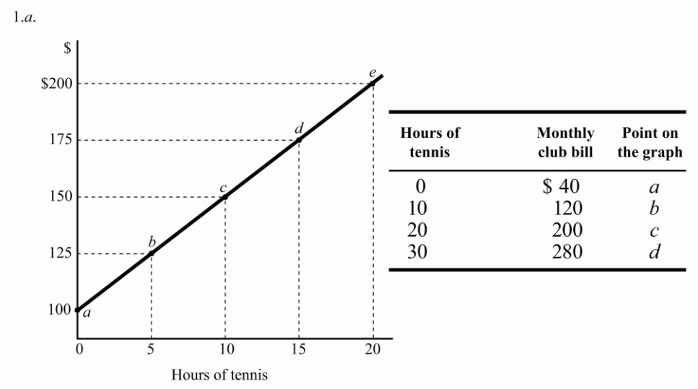

b. $5.00, hours/month

c. $15.00

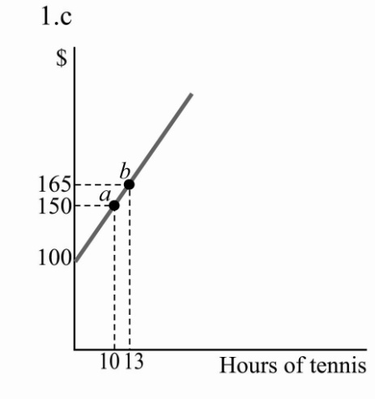

d. 6 additional hours

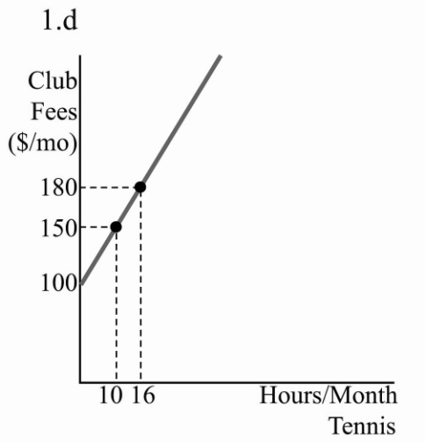

2. $20, $4.00, 10, $60, $80

3. a.

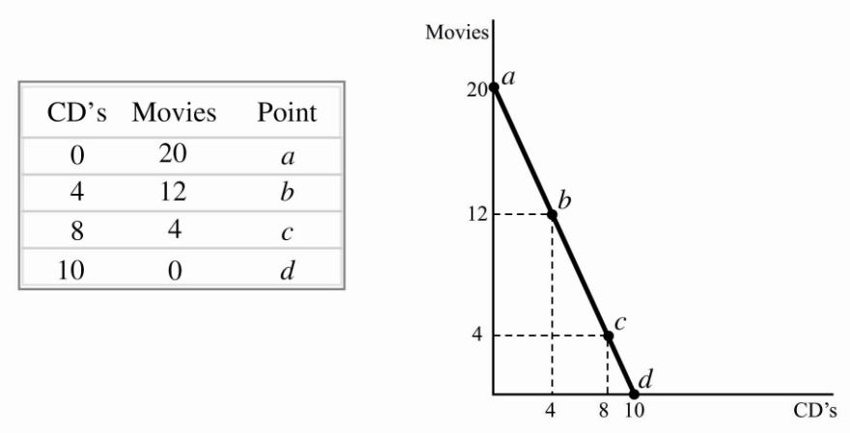

b. –2.0 movies, CD

4. a.

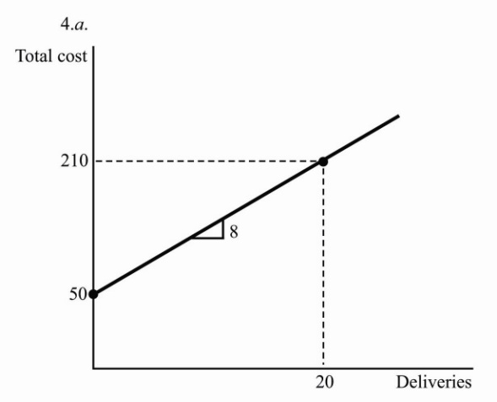

|  |  |
| --- | --- |
| **Number of Deliveries** | **Total Costs** |
| 0 | 50 |
| 5 | 90 |
| 10 | 130 |
| 15 | 170 |
| 20 | 210 |

b. $8.00, delivery

c. Drivers’ wages and the rental cost of the truck. In addition, the other costs of delivery, such as the price of fuel, insurance, and taxes.

d. deliveries

e. drivers’ wages, the rental cost of the truck, or the price of fuel

5. along, shifts

6. 10.0%, –2.0%, 6.0%

7. 112, 54, 23

8. 40% = 20/50, 33% = 20/60